C-programming

Matrix multiplication :-

#include <stdio.h>

int main() {
int m, n, p;

printf("Enter number of rows and columns of first matrix (m n): ");
scanf("%d %d", &m, &n);

printf("Enter number of columns of second matrix (p): ");
scanf("%d", &p);

int A[m][n], B[n][p], C[m][p];

printf("\nEnter elements of first matrix:\n");
for(int i = 0; i < m; i++) {
for(int j = 0; j < n; j++) {
scanf("%d", &A[i][j]);
}
}

printf("\nEnter elements of second matrix:\n");
for(int i = 0; i < n; i++) {
for(int j = 0; j < p; j++) {
scanf("%d", &B[i][j]);
}
}

for(int i = 0; i < m; i++) {
for(int j = 0; j < p; j++) {
C[i][j] = 0;
}
}

for(int i = 0; i < m; i++) {
for(int j = 0; j < p; j++) {
for(int k = 0; k < n; k++) {
C[i][j] += A[i][k] * B[k][j];
}
}
}

printf("\nResultant Matrix:\n");
for(int i = 0; i < m; i++) {
for(int j = 0; j < p; j++) {
printf("%d ", C[i][j]);
}
printf("\n");
}

return 0;
}
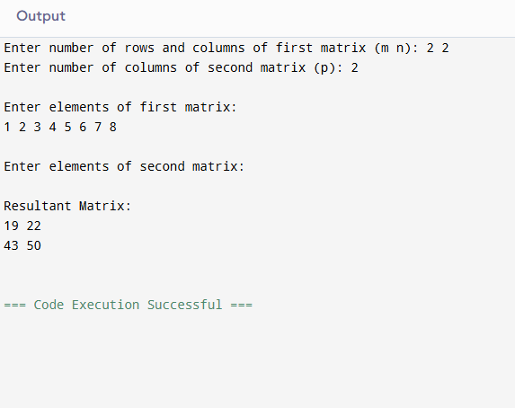

2.String palindrome without library functions.
Check whether a give string is a palindrome without using strrev().
Concepts:
.Strings
.Manual indexing

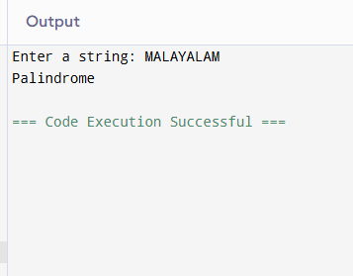
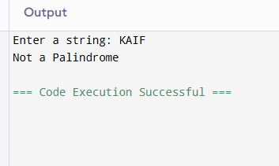

#include <stdio.h>
#include <string.h>

int main() {
char str[100];
int start, end, flag = 1;

printf("Enter a string: ");
scanf("%s", str);

start = 0;
end = strlen(str) - 1;

while(start < end) {
if(str[start] != str[end]) {
flag = 0;
break;
}

start++;
end--;
}

if(flag == 1)
printf("Palindrome");
else
printf("Not a Palindrome");

return 0;
}
3.File handling – count words , characters ,lines

#include <stdio.h>

int main()
{
FILE *fp;
int ch;
int characters = 0, words = 0, lines = 0;

fp = fopen("sample.txt", "r");

if(fp == NULL)
{
printf("File not found");
return 1;
}

while((ch = fgetc(fp)) != EOF)
{
characters++;

if(ch == '\n')
lines++;

if(ch == ' ' || ch == '\n' || ch == '\t')
words++;
}

if(characters > 0)
{
words++;
lines++;
}

fclose(fp);

printf("Characters = %d\n", characters);
printf("Words = %d\n", words);
printf("Lines = %d\n", lines);

return 0;
}
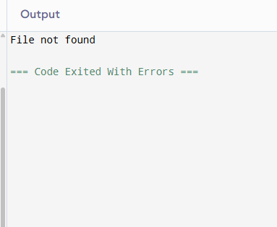

4. Structure – student records
#include <stdio.h>

struct Student
{
int rollno;
char name[50];
float marks;
};

int main()
{
struct Student s[5];
int i, topper = 0;

// Input student details
for(i = 0; i < 5; i++)
{
printf("Enter details of student %d\n", i + 1);

printf("Enter Roll Number: ");
scanf("%d", &s[i].rollno);

printf("Enter Name: ");
scanf("%s", s[i].name);

printf("Enter Marks: ");
scanf("%f", &s[i].marks);

printf("\n");
}

// Find topper
for(i = 1; i < 5; i++)
{
if(s[i].marks > s[topper].marks)
{
topper = i;
}
}

// Display topper details
printf("Topper Details\n");
printf("Roll Number: %d\n", s[topper].rollno);
printf("Name: %s\n", s[topper].name);
printf("Marks: %.2f\n", s[topper].marks);

return 0;
}
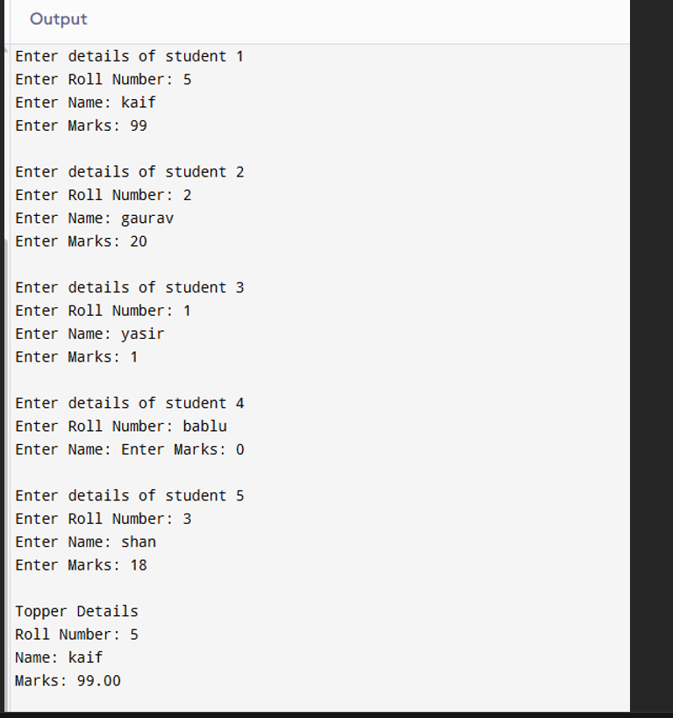

5.Pointer-based array sum
#include <stdio.h>

int main() {
int arr[] = {10, 20, 30, 40, 50};
int size = sizeof(arr) / sizeof(arr[0]);
int sum = 0;

int *ptr = arr;

for (int i = 0; i < size; i++) {
sum += *ptr;
ptr++;
}

printf("Sum of array elements: %d\n", sum);

return 0;
}
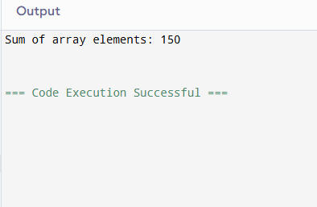

6.Sorting (without built-in)
// C Program for Bubble Sort
#include <stdio.h>

// Function to perform Bubble Sort
void bubbleSort(int arr[], int n) {
int i, j, temp;

for(i = 0; i < n - 1; i++) {

// Compare adjacent elements
for(j = 0; j < n - i - 1; j++) {

if(arr[j] > arr[j + 1]) {

// Swap elements
temp = arr[j];
arr[j] = arr[j + 1];
arr[j + 1] = temp;
}
}
}
}

// Function to print array
void printArray(int arr[], int n) {
int i;

for(i = 0; i < n; i++) {
printf("%d ", arr[i]);
}
}

int main() {
int arr[] = {64, 34, 25, 12, 22, 11, 90};
int n = sizeof(arr) / sizeof(arr[0]);

printf("Original Array:\n");
printArray(arr, n);

bubbleSort(arr, n);

printf("\n\nSorted Array:\n");
printArray(arr, n);

return 0;
}
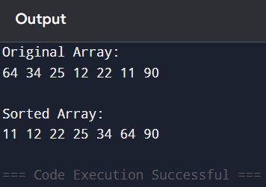

7.Fibonacci using recursion
// C Program to Generate Fibonacci Series using Recursion

#include <stdio.h>

// Recursive function to find Fibonacci number
int fibonacci(int n) {
if(n == 0)
return 0;
else if(n == 1)
return 1;
else
return fibonacci(n - 1) + fibonacci(n - 2);
}

int main() {
int n, i;

printf("Enter number of terms: ");
scanf("%d", &n);

printf("Fibonacci Series:\n");

for(i = 0; i < n; i++) {
printf("%d ", fibonacci(i));
}

return 0;
}
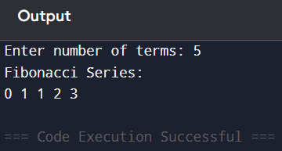

8.Find second largest element
// C Program to Find Second Largest Number in an Array
// Without Sorting

#include <stdio.h>
#include <limits.h>

int main() {
int arr[100], n, i;
int largest, secondLargest;

printf("Enter number of elements: ");
scanf("%d", &n);

printf("Enter array elements:\n");

for(i = 0; i < n; i++) {
scanf("%d", &arr[i]);
}

// Initialize values
largest = secondLargest = INT_MIN;

// Find largest and second largest
for(i = 0; i < n; i++) {

if(arr[i] > largest) {
secondLargest = largest;
largest = arr[i];
}

else if(arr[i] > secondLargest && arr[i] != largest) {
secondLargest = arr[i];
}
}

printf("Second Largest Number = %d", secondLargest);

return 0;
}
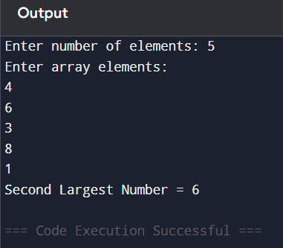

9.Menu driven calculator
// C Program using Functions, Switch Case and Loop Control
// Calculator Program

#include <stdio.h>

// Function declarations
float add(float a, float b) {
return a + b;
}

float subtract(float a, float b) {
return a - b;
}

float multiply(float a, float b) {
return a * b;
}

float divide(float a, float b) {
return a / b;
}

int main() {
int choice;
float num1, num2;

while(1) {

printf("\n===== Calculator Menu =====\n");
printf("1. Add\n");
printf("2. Subtract\n");
printf("3. Multiply\n");
printf("4. Divide\n");
printf("5. Exit\n");

printf("Enter your choice: ");
scanf("%d", &choice);

// Exit condition
if(choice == 5) {
printf("Program Exited");
break;
}

printf("Enter two numbers: ");
scanf("%f %f", &num1, &num2);

switch(choice) {

case 1:
printf("Result = %.2f", add(num1, num2));
break;

case 2:
printf("Result = %.2f", subtract(num1, num2));
break;

case 3:
printf("Result = %.2f", multiply(num1, num2));
break;

case 4:
if(num2 != 0)
printf("Result = %.2f", divide(num1, num2));
else
printf("Division by zero is not possible");
break;

default:
printf("Invalid Choice");
}
}

return 0;
}
